**Assignment 6**

1. Find the Armstrong Number between the two numbers which are input by user.

Sol.

lower = int(input("Enter the lower limit: "))

upper = int(input("Enter the upper limit: "))

for num in range(lower,upper + 1):

sum = 0

temp = num

while temp > 0:

digit = temp % 10

sum += digit ** 3

temp //= 10

if num == sum:

print(num)

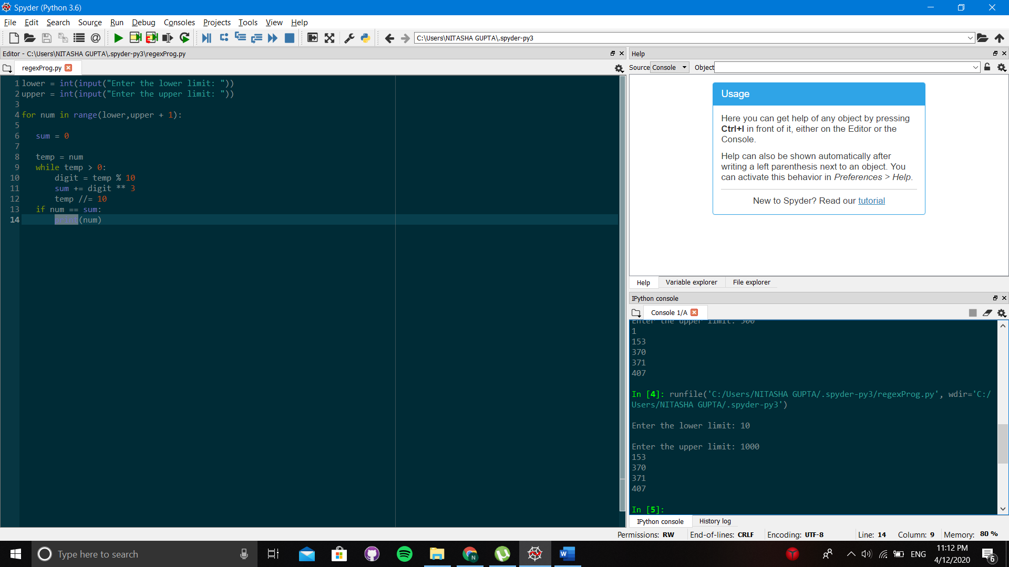

2. Remove the punctuation like [“@!#$%&*()”] from the string and output the string without them

Sol.

punc = '''!()-[]{};:'"\,<>./?@#$%^&*_~'''

my_str = str(input("Enter the string: "))

no_punc = ""

for char in my_str:

if char not in punc:

no_punc = no_punc + char

print(no_punc)

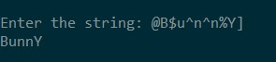

3. Sort the list of words in Alphabetical order.

Sol.

my_str = ['Apple', 'banana', 'cat', 'REGEX','apple'] #given

my_str.sort()

print(my_str)

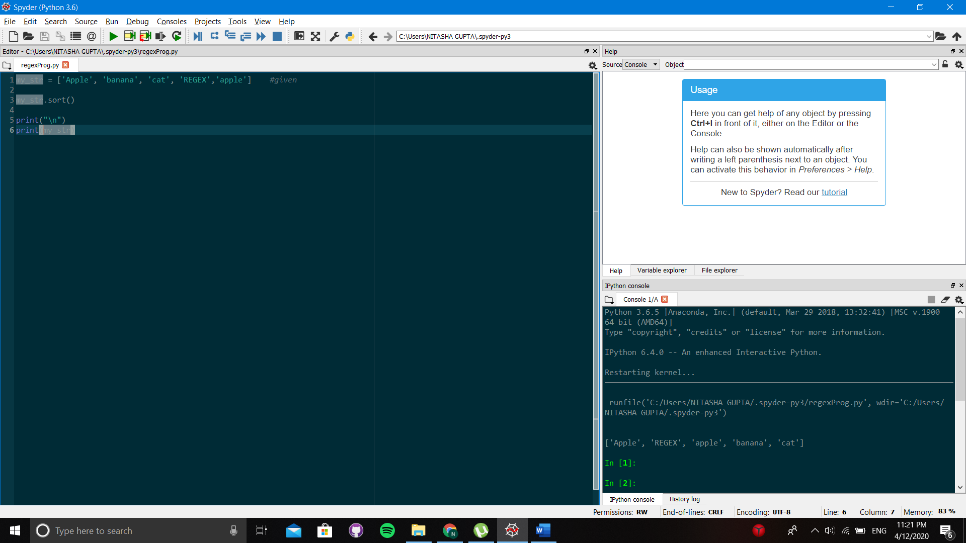

The reason for this type of order is due the ASCII value. For capital letters its starts from 65 whereas for small letters it starts from 97.